**What is Multitasking in Python?**

 



Multitasking, in general, is the **capability of performing multiple tasks simultaneously**.

In **technical** terms, multitasking refers to **the ability of an operating system to perform different tasks at the same time**. *For instance*, you are **downloading Postman**  something on your PC as well as **listening** to songs and **making word** file for presentation, etc.(Taskbar). All these tasks are performed by the **same OS an in sync**. This is nothing but multitasking which not just helps you **save time but also increases productivity.**

There are **two types** of multitasking in an OS:

* **Process-based -**Multiple things going on in os simultaneously ..listening to music ,word,etc .All are different tasks /processes .

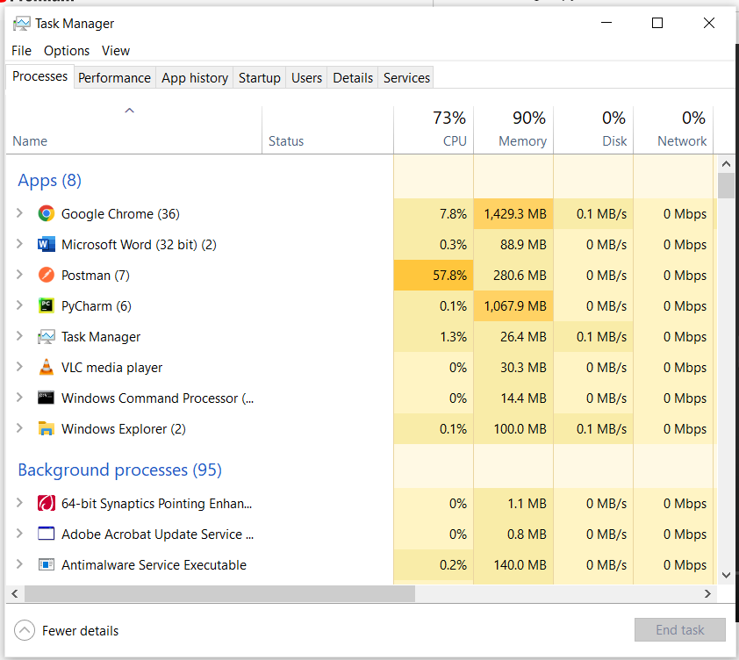

* **Thread-based**

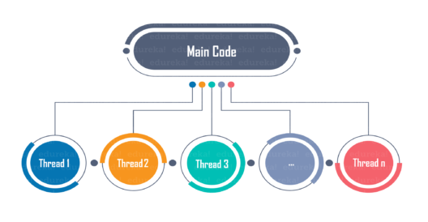

A **thread** is the **smallest unit of a program or process executed independently** or scheduled by the Operating System. In the computer system, an **Operating System achieves multitasking** by **dividing the process into threads**. A thread is a lightweight process that ensures the execution of the process separately on the system. In Python 3, when multiple processors are running on a program, each processor runs simultaneously to execute its tasks separately.

Every process has **one thread that is always running.** This is the **main thread.** This main thread actually creates the **child thread objects**. The child thread is also **initiated by the main thread**.

A **thread** is basically an **independent** **flow of execution**. A **single process can consist of multiple threads**. Each thread in a program performs a particular task. For Example, when you are **playing a game say FIFA** on your PC, the **game as a whole is a single process**, but it consists of **several threads** responsible for **playing the music**, **taking input** from the user**, running the opponent** synchronously, etc. All these are separate threads responsible for carrying out these different tasks in the same program.



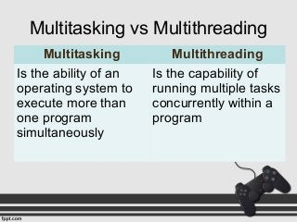

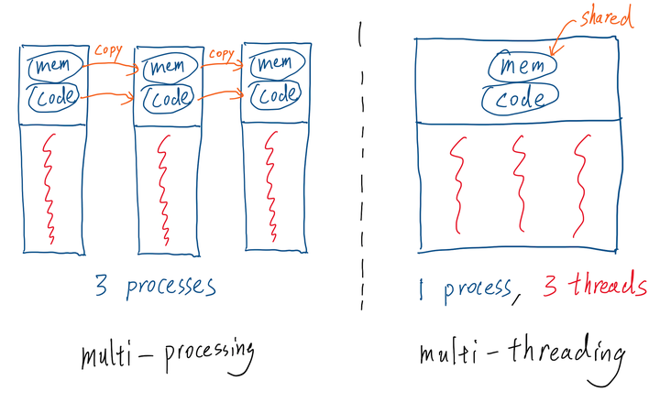

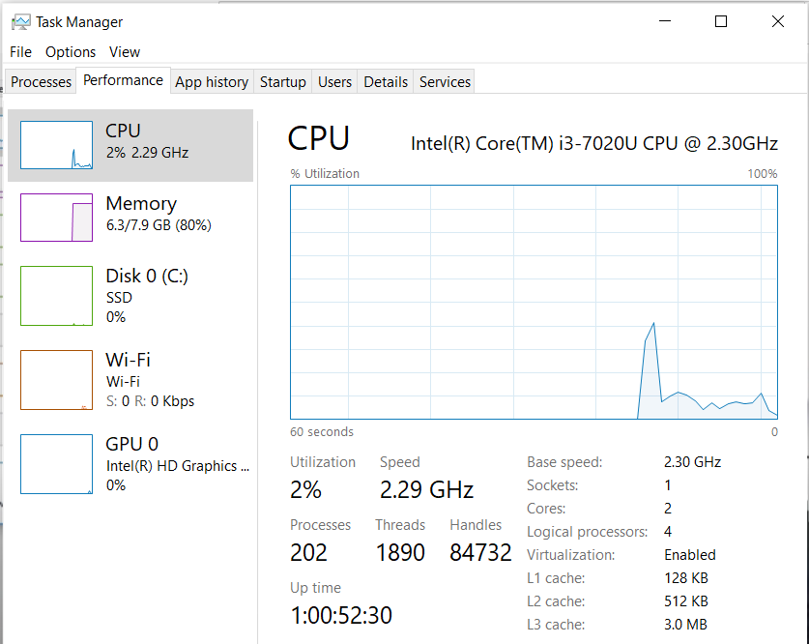

Note:Core is equivalent to processor (company 2 people)

**When to use Multithreading in Python?**

**Multithreading** is very useful for saving time and improving performance, but it **cannot be applied everywhere.**In the **previous FIFA example**, the **music thread** is **independent** of the thread that takes **your input** and the thread that takes your input is independent of the thread that **runs your opponent**. These threads run independently because they are **not inter-dependent.**

Therefore, multithreading can be used only when the **dependency between individual threads does not exist**.

It is a very useful technique for time-saving and improving the performance of an application.. Furthermore, it increases the user's responsiveness to continue running a program even if a part of the application is the length or blocked.

## ****Advantages of using threading****

## Multithreading allows the programmer to divide application **tasks** into sub-tasks and simultaneously run them in a program.

## It allows threads to communicate and share resources such as files, data, and memory to the same processor

Multithreading has many **advantages** some of which are as follows:

* **Better utilization of resources.**

**Economy**

It is more **economical** to use threads **as they share the process resources**

* **Simplifies the code**
* Allows **concurrent and parallel occurrence of various tasks.**

A **web browser** with multithreading can use **one thread for user contact** and **another for image loading at the same time**.Hence,**increases responsiveness**

**Reduces the time consumption or response time**, thereby, **increasing the performance.**

* To make the best use of the underlying processor and to improve the performance of our application, we can create multiple threads that can execute in parallel. **Making the best use of the processor** and also our application will give the best user experience, it will be fast.

## ****How to achieve Multithreading in Python?****

Multithreading in Python can be achieved by importing the **threading** module.

**import threading**

**Or**

**from threading import \***

## ****How to create threads in Python?****

Threads in Python can be created in **three ways**:

1. Without creating a class
2. By extending Thread class
3. Without extending Thread class

### **1 Without creating a class**

Multithreading in Python can be accomplished without creating a class **as well**. Here is an example to demonstrate the same:

**Example:**

|  |  |
| --- | --- |
| 1  2  3  4  5  6  7 | **from** threading **import** **\***  print(current_thread().getName())  **def** mt():      print("Child Thread")  child**=**Thread(target**=**mt)  child.start()  print("Executing thread name :",current_thread().getName()) |

**Output:**

MainThread

Child Thread

Executing thread name : MainThread

**Simple Programs :**

**from** threading **import** *  
  
  
*# Every process has one thread that is always executing i.e. Main thread***def** child():  
 print(**"Child Thread\n"**)  
  
  
t1 = Thread(target=child)  
*# created child thread and gave function 'child' to execute otherwise it will implement main thread*t1.start()  
*# to start child thread*print(**"Main thread"**)

Output :

Child Thread

Main thread

**case 2:**

**from** threading **import** *  
print(current_thread().getName())  
  
**def** child():  
 print(**"Child Thread:"**,current_thread().getName())  
t1=Thread(target=child)  
t1.start()  
  
print(**"Executing thread name :"**,current_thread().getName())

Output:

MainThread

Executing thread name : MainThread

Child Thread: Thread-35 (child)

**case 3 :**

**from** threading **import** *  
print(current_thread().getName())  
  
**def** child():  
 **for** x **in** range(6):  
 print(**"child is executing..\n"**,current_thread().getName())  
  
t1=Thread(target=child)   
t1.start()   
t1.join() *#makes main thread to wait*print(**"Executing thread name :"**,current_thread().getName())

output:

MainThread

child is executing..

Thread-32 (child)

child is executing..

Thread-32 (child)

child is executing..

Thread-32 (child)

child is executing..

Thread-32 (child)

child is executing..

Thread-32 (child)

child is executing..

Thread-32 (child)

Executing thread name : MainThread

Note:Before start control lies with Main thread .Main thread is one who creates child thread.

The above output shows that the **first thread that is present** is, the **main** thread. This main thread then **creates a child thread** that is **executing the function** and then the **final print statement is executed again by the main thread.**

Now let us move ahead and see how to do Multithreading in python by extending the Thread class.

### **2 By extending the Thread class(Most standard way):**

**Child class is created by** **extending the Thread class**, the child class represents that a new thread is executing some task. When extending the Thread class, the **child class can override only two methods** i.e. **the __init__() method and the run() method**. No other method can be overridden other than these two methods.

Here is an example of how to extend the Thread class to create a thread:

**import** threading  
**class** A(threading.Thread): *#inherit thread class present in threading module* **def** run(self):  
 **for** x **in** range(6):  
 print(**"child Thread"**)  
  
obj=A()  
obj.start()  
obj.join()  
  
print(**"control returned to Main thread.."**)

Output:

child Thread

child Thread

child Thread

child Thread

child Thread

child Thread

control returned to Main thread..

e.g.

**import** threading  
**class** A(threading.Thread): *#inherit thread class present in threading module* **def** run(self):  
 **for** x **in** range(6):  
 print(**"child Thread"**)  
  
obj=A()  
obj.start()  
obj.join()  
  
print(**"control returned to Main thread.."**)

Output:

child Thread

child Thread

child Thread

child Thread

child Thread

child Thread

control returned to Main thread..

e.g.

**from** threading **import** *  
**from** time **import** sleep  
  
**class** A(Thread): *#inherit thread class present in threading module* **def** run(self):  
 **for** x **in** range(6):  
 sleep(1)  
 print(current_thread().getName())  
  
obj=A()  
obj.start()  
obj.join()  
sleep(1)  
print(current_thread().getName())

Output:

Thread-16

Thread-16

Thread-16

Thread-16

Thread-16

Thread-16

MainThread

The above example shows that class A is inheriting the Thread class and the child class i.e A is **overriding** the **run** method. **By default**, the **first parameter of any class** function needs to be **self** which is the pointer to the current object. The output shows that the **child thread executes the run()** method and the **main thread waits for the childs execution to complete**. This is **because of the join()** function, which makes the main thread wait for the child to finish.

e.g.

**from** threading **import** *  
**from** time **import** sleep  
**class** A(threading.Thread): *#inherit thread class present in threading module* **def** __init__(self):  
 **for** x **in** range(6):  
 sleep(1)  
 print(**"child Thread"**)  
  
obj=A()  
*#obj.start()  
#obj.join()*sleep(1)  
print(**"control returned to Main thread.."**)

**e.g. 2 Child threads**

**from** threading **import** *  
**from** time **import** sleep  
  
  
**class** Child1(Thread):  
 **def** run(self):  
 **for** i **in** range(5):  
 print(**"child 1"**)  
 sleep(1)  
  
  
**class** Child2(Thread):  
 **def** run(self):  
 **for** i **in** range(5):  
 print(**"child 2"**)  
 sleep(1)  
obj1=Child1()  
obj2=Child2()  
  
obj1.start()  
obj2.start()  
  
obj1.join()  
obj2.join()  
print(**"Main thread"**)

Output:

child 1

child 2

child 1

child 2

child 1

child 2

Main thread

This method of creating threads is the **most preferred method** because its the standard method. But in case you want to create threads without inheriting or extending the Thread class, you can do it in the following manner.

**Without extending thread class**

To create a thread without extending the Thread class, you can do as follows:  
**Example:**

**class** ex:  
 **def** B(self):  
 L1 = [33, 44, 77, **'d'**, **'r'**]  
 **for** i **in** L1:  
 print(**"child"**, i)  
  
  
obj = ex()  
t1 = Thread(target=obj.B)  
t1.start()  
t1.join()  
print(**"done"**, current_thread().getName())

**Output:**

child 33

child 44

child 77

child d

child r

done MainThread

**Summary:**

**Multithreading** allows you to **break down an application/Process into multiple sub-tasks/threads** **and run these tasks/threads simultaneously**. If you use multithreading properly, your application **speed, performance, and rendering can all be improved.**